Project 2: Analysing of Educational Inequality across the USA

Group Neural Network
College of Arts and Sciences
MATH-014-04: Intro to Data Science
Dr Moussa Doumbia
April 13, 2026

Group Members: Annah Stevenson, Arissa Burns, George-Daniel Dixon, John Williams, Tanaysia Fields, Temiloluwa Owoade

Introduction
Education in the United States is often framed around the ideal of equal opportunity, yet research consistently shows that students' learning experiences vary dramatically based on factors outside their control (Smedley et al., 2001). Studies have found that American school funding is among the most unequal in the industrialized world, with the wealthiest districts spending nearly ten times more per student than the poorest; a stark contrast to many European and Asian countries that distribute school funding centrally and equitably (Smedley et al., 2001). This disparity disproportionately affects low-income and minority students, who are more likely to attend underfunded schools in urban or rural areas while neighbouring suburban districts operate with significantly greater resources (Urban Schools: Executive Summary, n.d.).
These inequalities do not exist in isolation. School type, student-teacher ratios, internet access, and demographic composition all interact to shape the educational experiences students receive. Understanding how these variables relate to one another, and to measurable outcomes like test scores and dropout rates, is essential for identifying where inequities are most severe and what factors drive them.
Objective
This project draws on a dataset of 1,000 U.S. schools across 10 states to explore these disparities, with a focus on how school type, funding, and demographic composition relate to each other and how this may impact student performance.

Materials and Methods
Material
- Cocalc Python 3 (Anaconda)
- Packages used: Seaborn, Matplotlib, Numpy, Pandas
- Project 2 Instructions
- Kaggle dataset: education_inequality_data.csv
The Education dataset contained 11 columns: school name, state, school type, grade level, funding per student in USD, average test score percent, student-teacher ratio, percent low income, percent minority, internet access percent, and dropout rate percent.

Method
The dataset was first loaded into a Jupyter Notebook environment using Python, and key libraries such as Pandas, Matplotlib, and Seaborn were imported for data manipulation and visualisation.
Before analysis, the dataset was examined for inconsistencies, missing values, and formatting issues, of which it had none. Categorical variables and numerical variables were grouped together and examined to allow easy cleaning as per instructions in the Project 2 handout. This ensured accurate grouping and comparison during visualisation. We obtained a summary of the data, as shown in Figure 1.

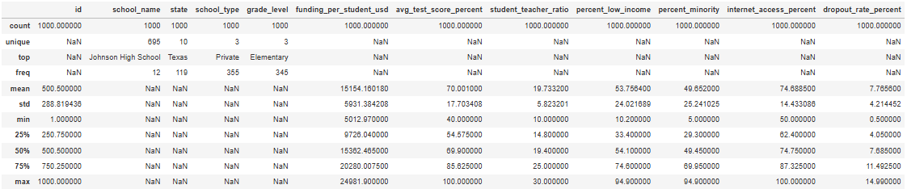
Figure 1: Overview of the Dataset: Summary Statistics The table shows descriptive statistics for 1,000 schools across important variables. The average amount of funding per student is around $15,154, with a range of approximately $5,013 to approximately $24,982, indicating significant resource differences. The student-teacher ratio is approximately 19.7, and the average test score is 70%. With an average of 53.8% low-income kids and 49.7% minority students, schools serve a diverse student body. The average dropout rate is 7.8%, with a range of 0.5% to nearly 15%, while the internet access percentage is approximately 74.7%.

We used Seaborn and Matplotlib to create a variety of visualizations that explore distributions, comparisons, and relationships within the dataset. These included histograms, bar charts, scatter plots, and correlation heatmaps. The data showed a diverse yet relatively uniform set of important factors that skew the data. For instance, as shown in Figures 2 and 3, there is a relatively balanced representation of each school type and student-to-teacher ratio.
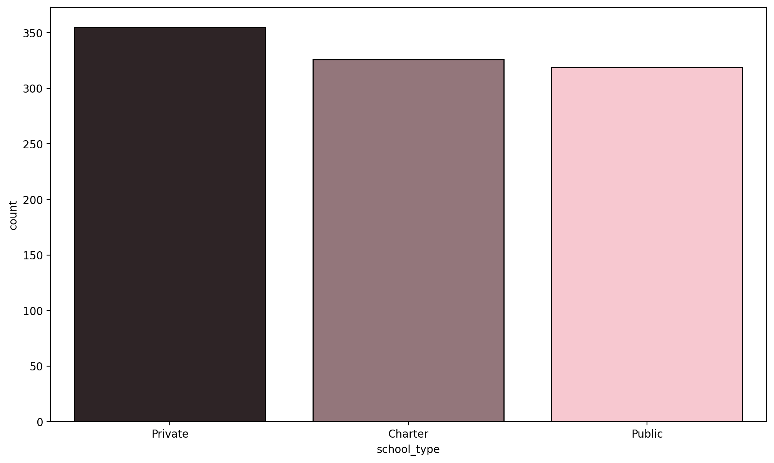
Figure 2. Distribution of School Types and States: This count plot shows the distribution of schools by type, including public, private, and charter institutions. The visualisation reveals a relatively balanced distribution among the three categories, with private schools appearing slightly more frequently.
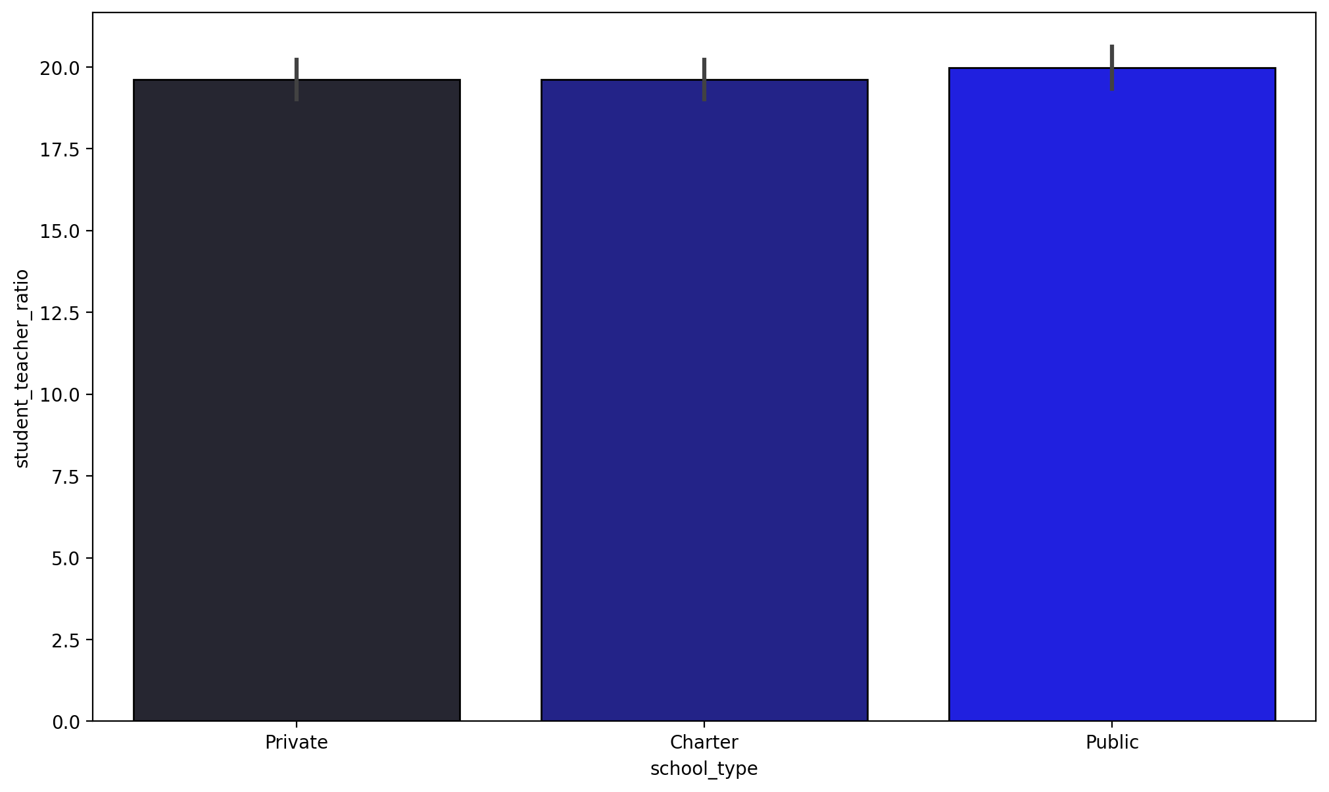
Figure 3. Student-Teacher Ratio – Private vs. Public Schools: Both private (~19.7) and public (~20) schools show nearly identical student-teacher ratios, with overlapping error bars confirming the difference is minimal. This suggests class size is not a distinguishing factor between the two school types in this dataset.

Storytelling

The education inequality dataset is crucial to understanding the different challenges our education system faces, particularly the most vulnerable communities in these United States (Local Education Inequities Across U.S. Revealed in New Stanford Data Set, 2026). Throughout our project we were able to develop data visualizations that bring about unsurprising, although meaningful insights for educational inequality.
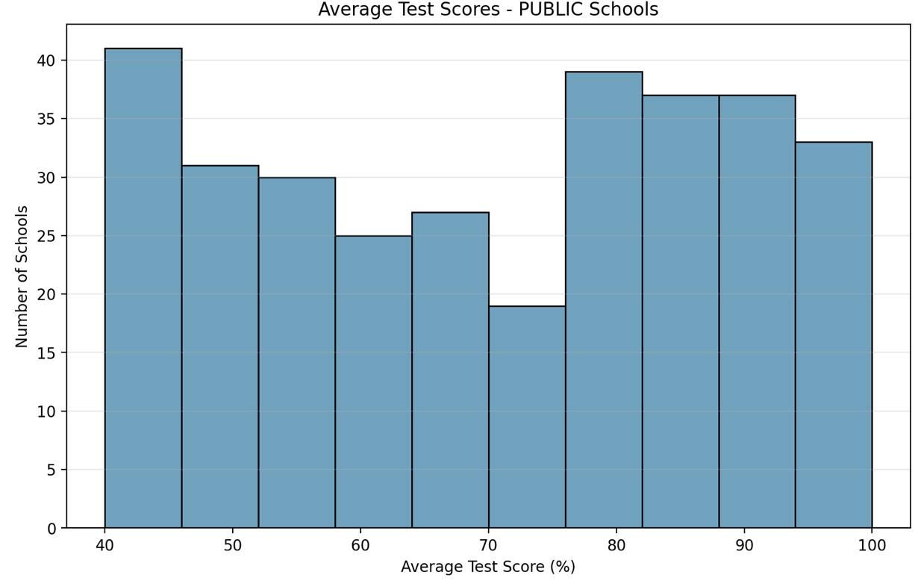
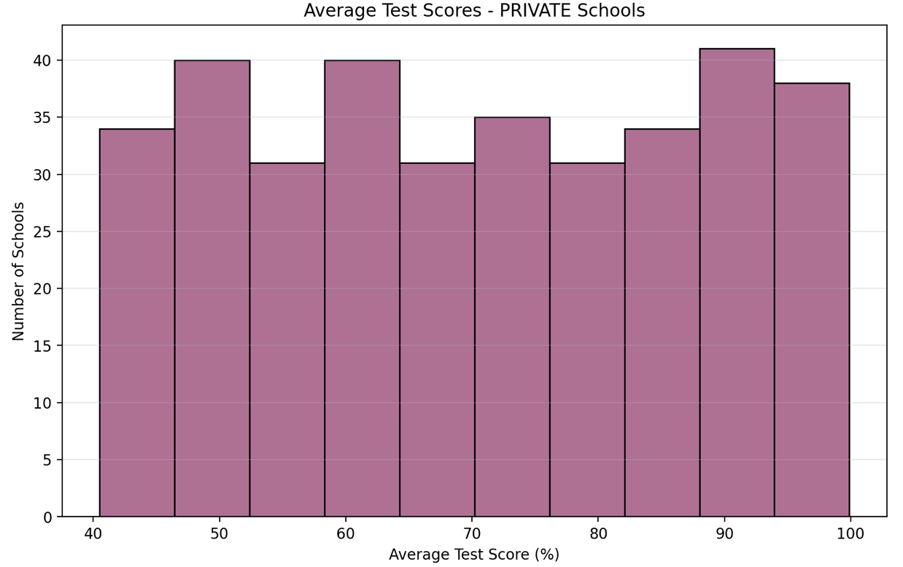

Figure 4: Average Test Score Distribution for Private vs. Public Schools The distribution of average test scores in public and private schools is contrasted in the histograms. All score levels (40–100%) show a very uniform distribution in private institutions. Public schools have a right-skewed pattern with a secondary peak in the higher range (80–90%) and a concentration of schools scoring in the lower range (40–50%). In general, public schools exhibit more volatile results, whereas private schools seem to preserve a more balanced distribution.

These data illustrations depict average test schools in private (left) versus public (right) schools. The x-axis displays the average test scores in percentages and the y-axis displays the number of schools. If we were to adopt the letter grading system in American schools systems, anything above a seventy is a passing grade or a C, the graphs suggest that private schools have a slightly better average.
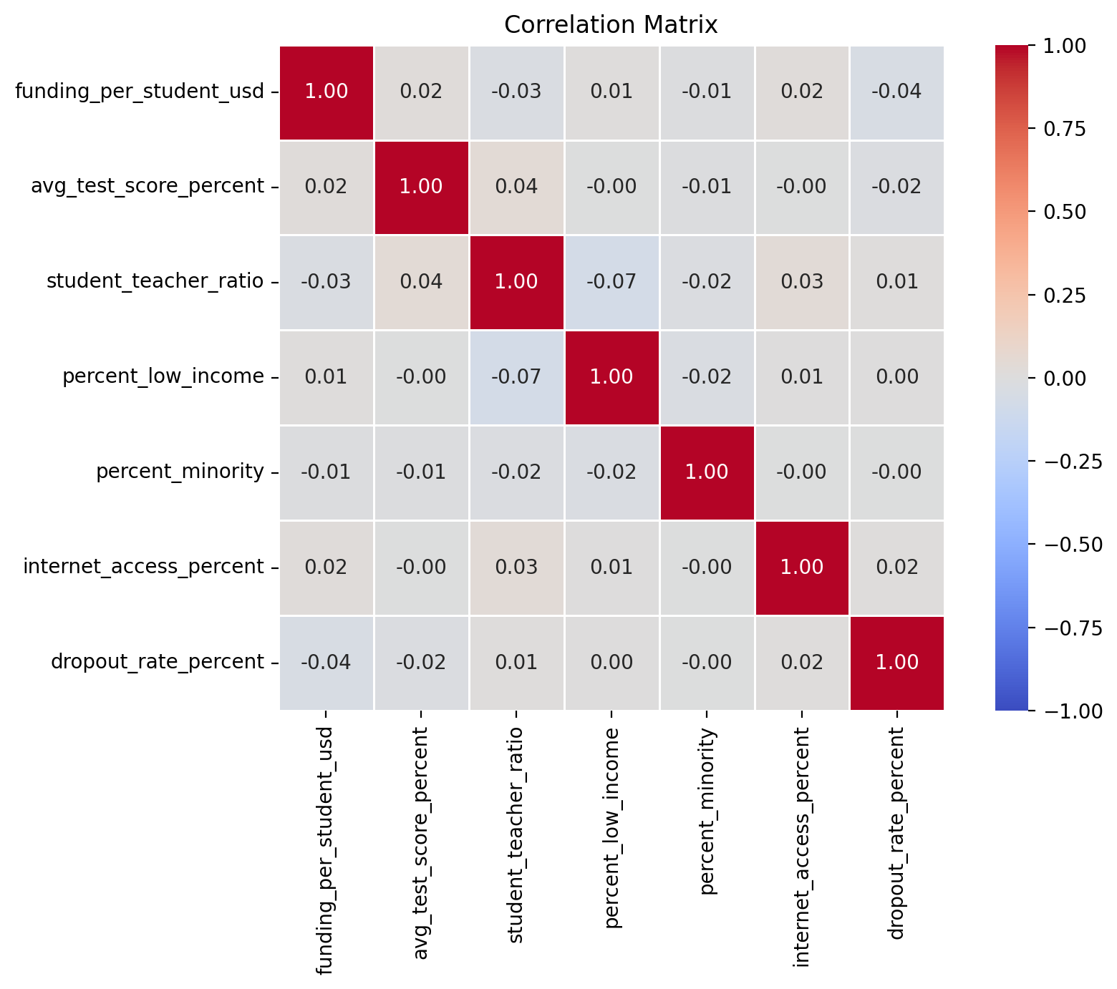
Figure 5: Correlation Matrix Shows No Strong Linear Relationships Found: The heatmap shows that most variables have very weak correlations with each other, as the values are close to zero. This indicates that no single factor, such as funding or demographics, strongly predicts student outcomes on its own. Instead, educational outcomes are likely influenced by a combination of multiple factors.

We created a correlation heatmap to find any significant connections between important factors. However, the results showed almost no correlations between any pair of variables, indicating that no single factor, such as funding, class size, or internet availability, has a strong linear link with outcomes like test scores or dropout rates. This made us believe there are more complex trends across school kinds and demographics rather than just correlations.

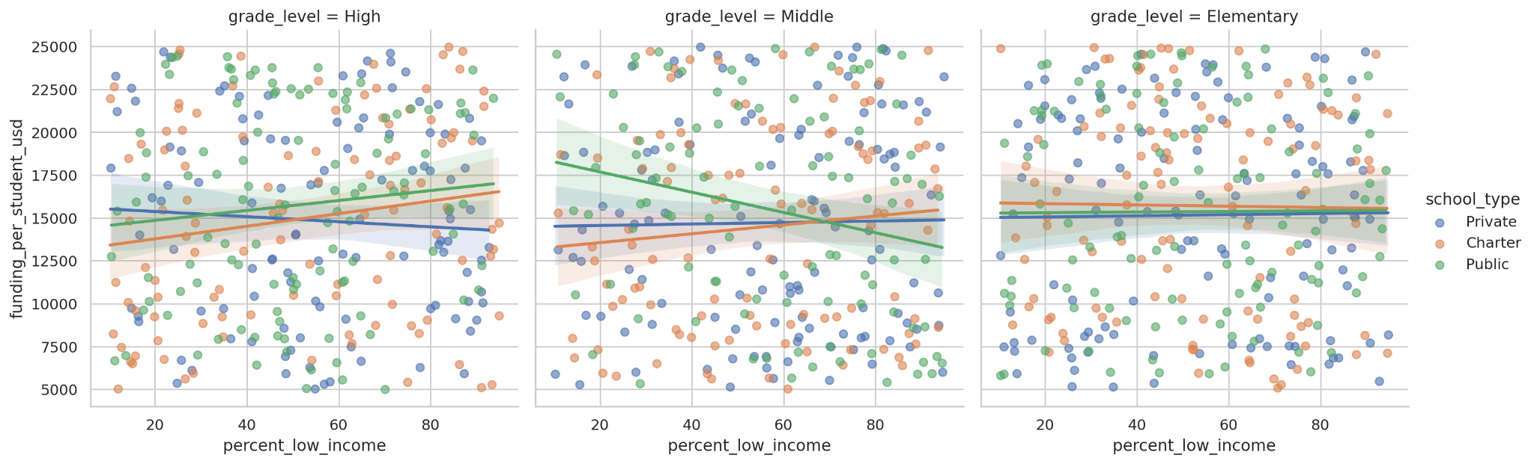

Figure 6: Funding vs. Low-Income Enrollment by Grade Level & School Type: Funding does not consistently correlate with low-income enrolment across all grade levels. Middle schools have the greatest fluctuation; elementary schools stay mostly level, while high schools show somewhat opposing trends by school type. The broad distribution of data shows that low-income enrolment alone cannot accurately predict funding levels.

This illustration above is consequential to our analysis and provides meaningful insights. This scatterplot splits education level into its three categories: elementary, middle, and high school. It measures funding per student combined with percentages of low-income students alongside identifying if those students are enrolled within a private, public, or charter school. These results indicate that in high school, there is a positive correlation between low-income students and funding per student in charter and public schools. This means that a higher percentage of low-income students indicates an increase in funding. Private school shows a slight negative correlation, suggesting that the more low-income students the school has, the less funding per student the school receives.
In middle school, public schools tend to have a negative correlation, suggesting that an increase in low-income students will lead to a decrease in per-student funding. In contrast, charter schools and private schools show a linear status, indicating minimal correlation. In terms of elementary, all of the school types are linear meaning that the percentage of low income students do not necessarily indicate an increase or a decrease in funding per student. Notably, private schools are less elastic than public schools, meaning that the percentage of low-income students does not change the funding per student to the same degree it would affect public schools. We see that clearly in the middle school section.

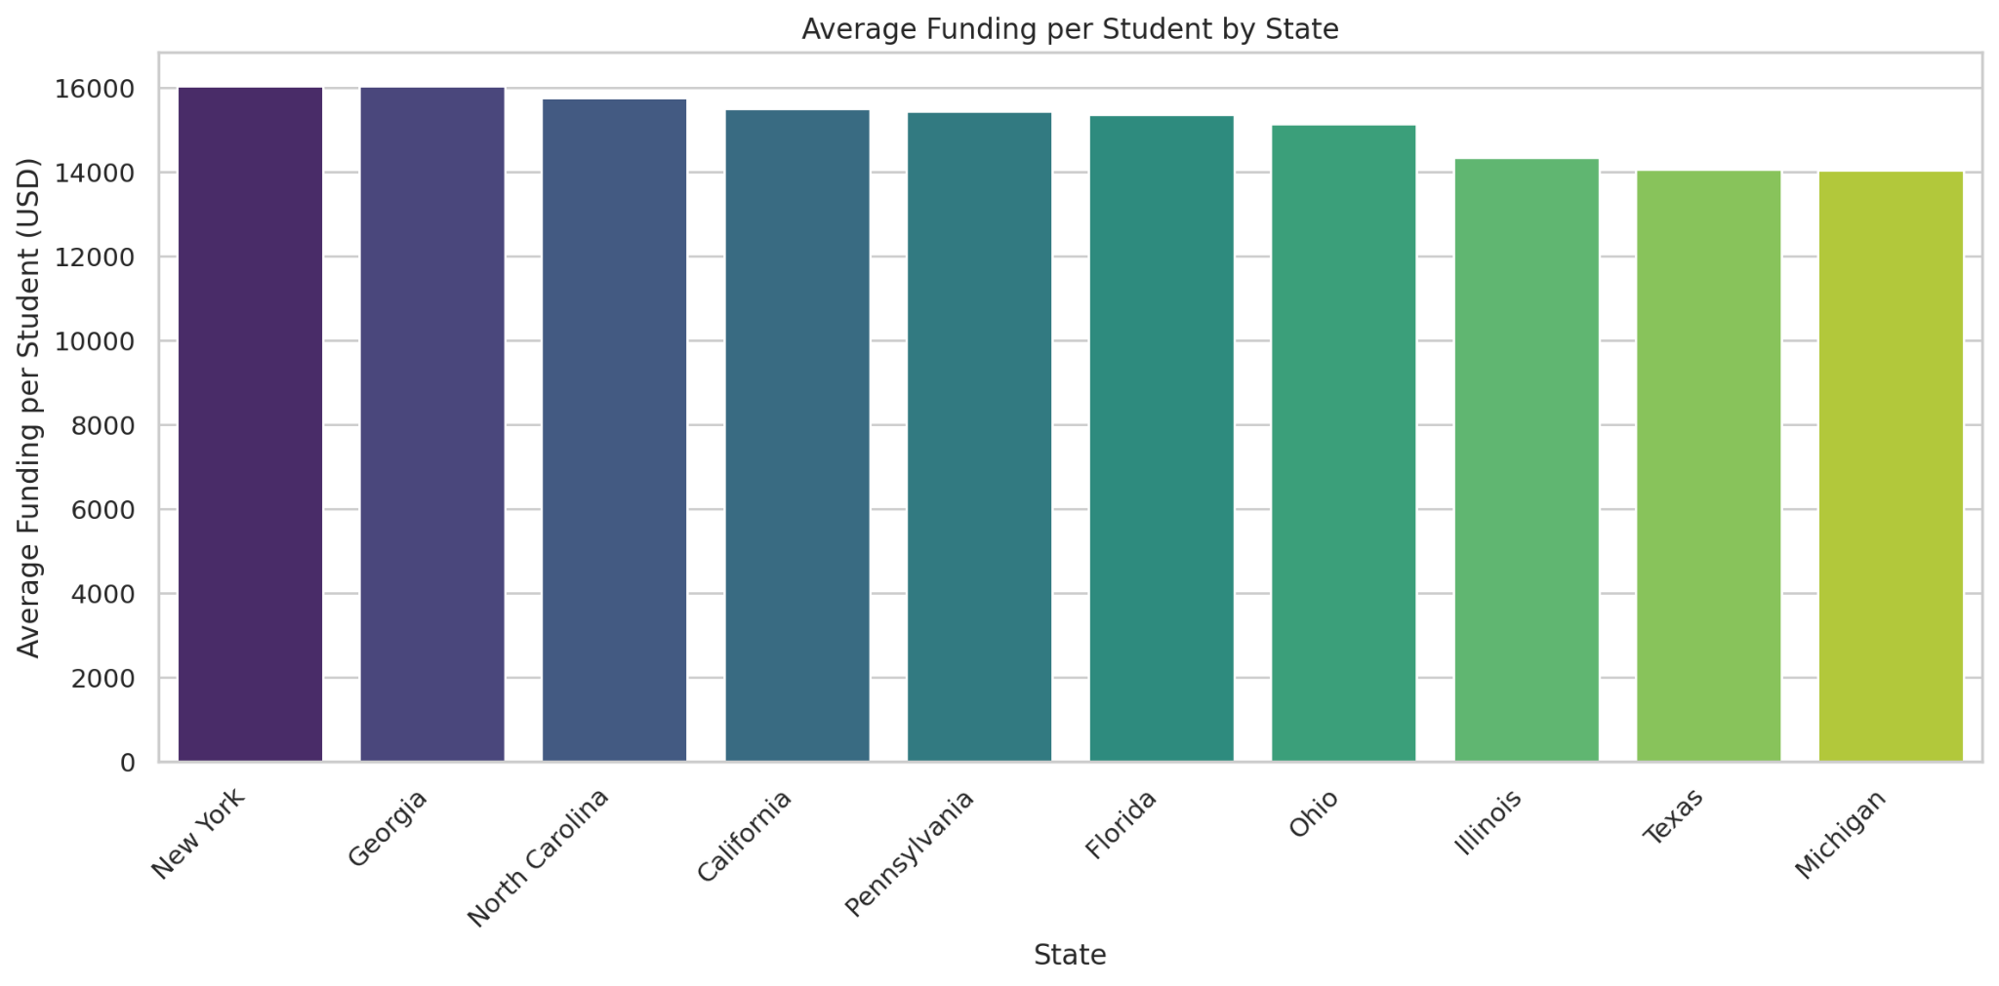
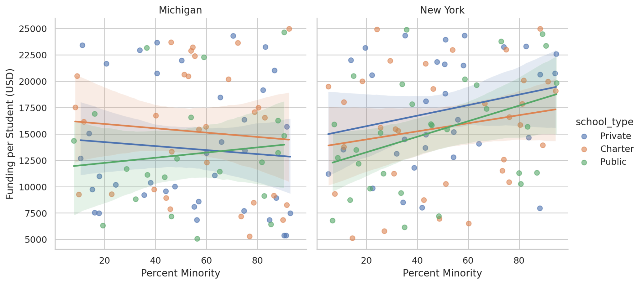
Funding by State and Minority Enrolment, Figures 7a and 7b: Ten states' average per-student financing is displayed in Figure 7a, with Michigan coming in last at around $14,000 and Georgia and New York leading at about $16,000. Building on this, Figure 7b examines minority enrolment and school type in the two most disparate states, Michigan and New York. Michigan has more erratic patterns, demonstrating how the same budget difference manifests itself differently at the school level, while New York exhibits a positive funding trend across all school types as minority enrolment rises.

We then moved our attention to the difference across the 10 states in our dataset. We initially looked at the average per-student financing for each of the states in our dataset to comprehend regional funding disparities. At about $16,000 per student, New York and Georgia had the most support, while Texas and Michigan had the lowest, averaging about $14,000 (Figure 7A). We were drawn to the almost $2,000 difference in financing between the states with the greatest and lowest levels of funding, which prompted us to consider the potential impact of financial disparities on educational results. We looked more closely at how these two states differ in terms of school types, demographics, and performance indicators, particularly because of the stark discrepancy between New York and Michigan (Figure 7B).
As minority enrolment rises in Michigan, funding for private and charter schools trends slightly downward, while funding for public schools shows a tiny upward trend. This suggests that higher-minority public schools may receive slightly more resources. In contrast, all three school types in New York exhibit a positive funding trend when minority enrolment increases, which may be due to the state's more robust equity-driven funding regulations. The large range of data points in both states indicates substantial variability despite these directional changes, indicating that funding levels are not consistently determined by minority enrolment alone. This supports the notion that a complex combination of factors other than demography causes funding inequities.

Conclusion
This project highlights the complexity of education inequality in the United States. Through data visualization and analysis, we found that funding varies significantly across states. Socioeconomic factors such as income level and demographic composition are associated with educational outcomes.
The scatterplots demonstrated that the relationship between income and funding differs across school types. Our histograms and bar charts revealed differences in performance and demographic distribution between private and public schools. The correlation heatmap showed that most variables have weak relationships, indicating that no single factor fully explains student outcomes.
These results suggest that education inequality is shaped by multiple interacting factors. These factors include funding, demographics, and geographic location. Understanding these relationships is essential for addressing disparities and improving equity within the education system.

References
Education inequality data. (2025, July 29). https://www.kaggle.com/datasets/shamimhasan8/education-inequality-data/data

Smedley, B. D., Stith, A. Y., Colburn, L., & Evans, C. H. (2001). Inequality in teaching and schooling: How opportunity is rationed to students of color in America. The Right Thing to Do, the Smart Thing to Do - NCBI Bookshelf. https://www.ncbi.nlm.nih.gov/books/NBK223640/

Urban Schools: Executive Summary. (n.d.). https://nces.ed.gov/pubs/web/96184ex.asp

Local education inequities across U.S. revealed in new Stanford data set. (2026, March 24). Stanford Graduate School of Education. https://ed.stanford.edu/news/local-education-inequities-across-us-revealed-new-stanford-data-set

